Michigan Virtual School® – Consortium Orientation
Catalog Enrollment Management System (CEMS)

Enrolling students, emptying shopping cart and completing payment for MVS Courses
Step 1: Go to MVS website, www.mivhs.org and enter your username and password

.

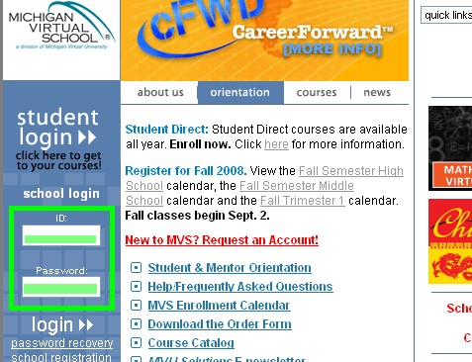

- If your school has a scholarship, click on (Scholarship) to confirm the seat or seats have been added.

- Students must be created before they can be enrolled. To view students in the system, select Students and choose both active and inactive in the drop down box to view all students.

Step 2: To enroll students in courses, from the left navigation bar, select Enrollments then select Create Enrollment.

Second

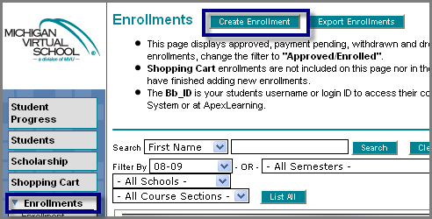

First
For multiple school users, make sure that the correct school is selected.

Step 3: Check the box and make the appropriate selection for each student in the mentor and enrollment reason categories then select Add to Shopping Cart. After other course/student selections, select Add to Shopping Cart.

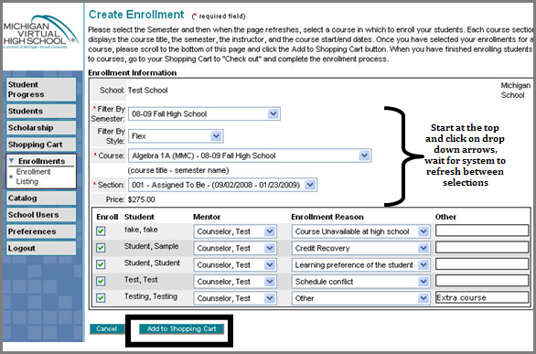

The next screen shows the enrollment has been added to the shopping cart. Continue enrolling students/courses.

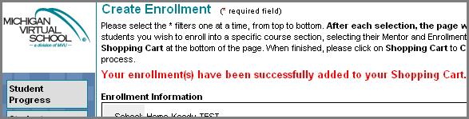

Step 4: Shopping Cart

- After all students and courses have been selected, select the Shopping Cart to view enrollments. Make sure the information is correct and delete duplicates or incorrect information.

- To add any enrollments, select Enrollment and enroll students in additional courses.

- After review, to complete enrollment, select Checkout.

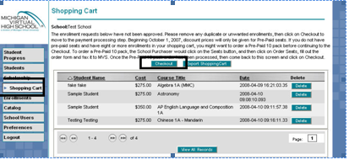
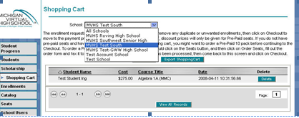

For multiple school users, select the school enrollments for checkout. Each school with enrollments will need to be checked out separately.

Step 5: Payment Type

This screen displays the enrollment and payment type information.

Scholarship Seats – If the school is participating in any scholarship opportunities, the student enrollment information would be displayed here.

Pre-Paid Seats – Pre-purchased seats appear here.

Unpaid Seats – Consortium enrollment students/enrollments will be displayed here, select Purchase Order.

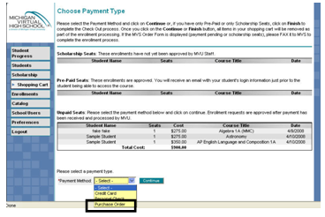

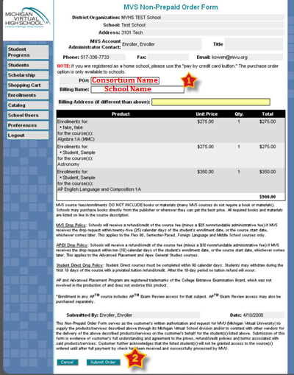
Step 6: Purchase Order Information

*Enter Consortium Name in the PO# area

*Enter School Name in the Billing Name.

*Select Submit Order

Step 6: Purchase Order Information

- Enter Consortium Name in the PO# area

and enter School Name in the Billing Name

- Select Submit Order

Next is a copy of the MVS Order Form:
Save or make a copy for your files.
For faster service, email cems@mivu.org to notify the MVS staff of your school/consortium enrollments.
- In the Subject area enter the consortium name
- In the Body of the message list the school name. Do not include students/classes.

You will receive a confirmation email that the enrollment has been received.

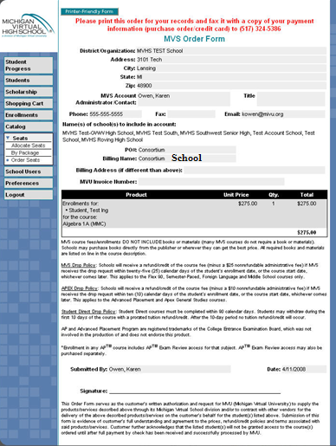

Michigan Virtual School®
www.mivhs.org Toll Free - 888-532-5806
Email any questions to: mentor@mivu.org

Help Desk 888-889-2840

